001510401130

pulkit kushwaha

bce iii

001510401130

**RAILWAY**

SIGNALLING AND CONTROL

**railway signalling and control**

# **introduction**

The purpose of signalling and interlocking is primarily to control and regulate the movement of trains safely and efficiently. Signalling includes the use and working of signals, points, block instruments, and other allied equipment in a predetermined manner for the safe and efficient running of trains. Signalling enables the movement of trains to be controlled in such a way that the existing tracks are utilized to the maximum.

In fact in railway terminology signalling is a medium of communication between the station master or the controller sitting in a remote place in the office and the driver of the train.

**THE EARLY HISTORY OF RAILWAY SIGNALLING**

In the early days, each railway company employed men called policemen who were posted at stations, junctions and other important places such as level crossings, to control the running of trains. Initially they signalled to the drivers using hand signals. These early policemen were organised very similarly to the Metropolitan Police and their duties included keeping general law and order on railway premises and removal of trespassers as well as operating points and signalling trains.

In 1860 the first installation in which levers were interlocked so that signals could not be ‘cleared’ until points were properly set, was brought into service. This principle of interlocking has remained with railways ever since and is fundamental to the safety of any signalling and train control system. Another such principle became known as ‘fail-safe’ and this too had to be learned in the hard school of experience. Originally fixed signals had to be turned or moved in some way to indicate a clear road. Because of a number of accidents with this type of arrangement, it soon became apparent that signals could stick in the clear position or wires could break without the possibility of turning the signal to the danger position. Following this all semaphore signals were designed to have counterbalance weights which returned the signal to a ‘danger’ position in the event of failure of any components. These two principles of interlocking and failsafe remain today and are fundamental to the safe operation of all signal equipment and systems. The other great need in early railways was to have some form of communication between signal boxes. Again by about 1860 a simple method of indicating that a train was ‘on line’ or ‘clear was invented giving this vital link for the first time. The system was made possible by an arrangement of electro-magnets with a low current passing through to indicate by a needle whether or not a train was still on the line between the boxes or had passed to the next section of a track. This was a tremendous step forward and removed for good the danger of a broken down train blocking the path of the next train which was signalled through on the assumption that sufficient time had elapsed for the road to be clear.

**Objectives of Signalling**

The objectives of signalling are as follows.

(a) To regulate the movement of trains so that they run safely at maximum

Permissible speeds.

(b) To maintain a safe distance between trains that are running on the same line

in the same direction.

(c) To ensure the safety of two or more trains that have to cross or approach

each other.

(d) To provide facilities for safe and efficient shunting.

(e) To regulate the arrival and departure of trains from the station yard.

(f) To guide the trains to run at restricted speeds during the maintenance and

repair of tracks.

(g) To ensure the safety of the train when it comes in contact with road traffic at

level crossings.

**Classification of Signals**

Railway signals can be classified based on different characteristics

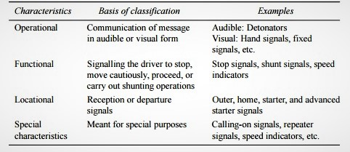

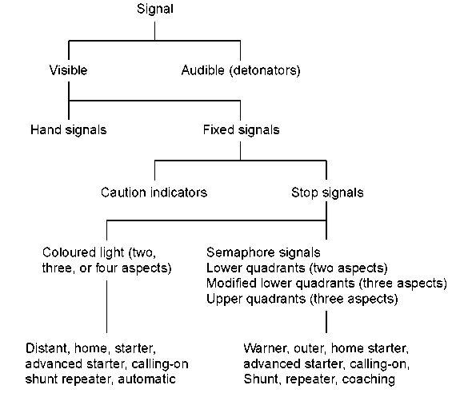

Minimum signal requirements of various classes of stations

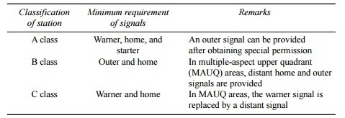

**Semaphore Signalling**

• Semaphore signals are rectangular or fish tailed arm fixed to a vertical Post.

• The arm is rotated in different angles to convey information to the Loco driver.

**Stop Dead Aspect Proceed Aspect**

**COLOUR LIGHT SIGNALS**

In This type of signaling colour lights are

used to convey information to the Loco

driver. This has many advantages over

semaphore signals. They may be

elaborated as follows:

1. The day and Night aspects are the

same, so no confusion to the driver.

2. Visibility can be available for Longer

ranges, so it is easier for the driver to apply

brakes in time.

3. The Signals are placed at drivers Eye

Level.

4. No Mechanical Transmission and no

moving parts.

**Elements of a Yard**

• Signals

• Track Circuits

• Points

• Slots

**WARNING SIGNALS**

They provide a pre-hand warning to the

driver about the controlling signals ahead.

These only enhance the efficiency and

provide a further safety caution

**STOP SIGNAL**

* The length and width of arm vary from 120-167

cm and 23-25 cm respectively.

* The outer end of the arm is about 2.45 cm

broader than that of the hinged end.

* It is placed on the left hand side of the direction

of movement of train.

* The side of the arm facing the driver is painted

red with white band near the end.

* The other side is painted white with black

bands.



**WARNER SIGNAL**

* Signals place ahead of the stop signals to warn driver before entering the station.
* These signals are similar to stop signals with the exception that at their free end V notch is cut to distinguish it from stop signals.
* Warner signals are placed generally at about 540 m away from the stop signals.

**SIGNAL INDICATIONS**

* ****Inclined Position

Track is clear and driver can proceed with

confidence.

* Horizontal position

Driver can take his train up to stop signal

cautionsly.

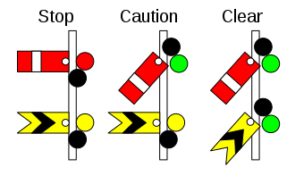**SEMAPHORE AND WARNER SIGNAL**

* Semaphore and

Warner signals can be

placed on same the

pole .

* Semaphore is placed

on top and the Warner

at about 2m below it.

**DISC SIGNAL**

These are shunting signals which

are used for low speed movement

during shunting operations. They

consists of circular discs with red

bands on white background.

**TRACK CIRCUITS**

The simplest and most effective way of detecting that there is no train on

a particular length of track is by the use of the track circuit which is shown

in diagrammatic form..

In this simple arrangement, the current flows from the battery to the

relay through the rails and the green light is operated from the relay. When

an approaching train reaches the section, the axles short circuit the current from the relay which then drops and the green light goes out and a red light

comes on, fed from the relay contact.

This is a ‘fail-safe’ arrangement as if the battery goes flat, a rail breaks

or a contact becomes loose etc, the result is the green light goes out and thred light comes on.

There are many types of track Circuits

available as follows:

1. DC Track Circuits

2. High Frequency Track Circuits (HFTC)

3. Audio Frequency Track Circuits (AFTC)

4. Axle Counters ( Digital & Analog )

What ever may the technology used to

detect presence of train, the final element is

a relay.



**POINT OPERATION, LOCKING AND DETECTION**

To prevent points coming open, they are locked in position for a facing

move and to ensure that the train is not allowed to proceed over them until

they are safe, they are ‘detected’ to be in the correct position, fully ‘home’

and locked.

The lock is held until it is proved that there is no train passing over the

points by means of the track circuits, and is applied from the moment that

a train approaches to within its braking distance of the toe of the points.

This is to prevent a signal man from moving the points after a train has

accepted a signal.

Points on early railways were operated by hand worked levers, usually

close to the points themselves. Later, they were still hand operated but the

levers were more remote from the points and grouped into frames, along with signal levers. Considerable skill and strength was required to ‘throw’

point levers that were some distance from the points because of the friction

and inertia to be overcome.

Although some points in depots and sidings continue to be hand worked,

most modem railways now use some form of motor to move points from one

position to another. These motors are usually electrically driven but can be

driven by compressed air, as on the London Underground.

With modem point motor assemblies, devices are integrated into the

mechanism which will lock the points in position once they are fully home

and will also electrically detect that they are actually fully closed. They

have the added advantage of being able to detect the presence of an

obstruction, such as a discarded can, in the point blades.

**Slots**

• A slot is an element of a Yard, which as dual Control, i.e. An Element of the Yard

which can be operated by Two or More means.

• This is generally applicable for Points, level Crossings and Ground Frames

Example: Normally a Point is operated by means of Electric Motor but whenever the motor is failed, a permission is granted by the station Master of that yard to the signalling department, so that the field staff Can go and manually operate the point and lock it. This is done by the means of a crank handle. So that there is no detention of traffic.

**Interlocking**

The interlocking of signals and points is another principle born out of hard

experience in the early days, which is now universally adopted. In essence

interlocking is introduced to prevent signal men accidentally clearing a

signal before points are properly set or clearing signals that would allow a

conflicting movement. In manual boxes, a series of sliding bars is connected

to the levers. These bars have notches and dogs in them which will only

allow operation of the signals in correct relationship to other signals and

when relevant points are correctly set.

Similar devices are incorporated into power operated boxes which follow

the same principles and prevent operation of signals or points for conflicting

moves. Similarly signals cannot be cleared in areas of pointwork until the

correct route is set and all trains are clear.

From the foregoing, it can be seen that railway signalling is basically

simple and can be made absolutely fail-safe for all conditions providing the

following three basic sub-systems are in place and working:

* Track circuits
* Point locking and detection
* Interlocking

**CONCLUSION**

* To safety receive and dispatch trains at station
* To control the movements of trains from one station to another after ensuring that the track on which this train will move to reach the next station is free from movement of another train either in the same or opposite direction. This Control is called block working.
* Preventing the movement from opposite direction is necessary in single line track as movements in both directions will be on the same track.

**REFERENCES**

* [www.railroadsignals.us/basics/basics1.htm](http://www.railroadsignals.us/basics/basics1.htm)
* [www.irfca.org/faq/faq-signal.html](http://www.irfca.org/faq/faq-signal.html)
* <https://www.scribd.com/document/369791051/Railway-Signalling-Einzelseiten-pdf>
* <http://www.iriset.indianrailways.gov.in/>
* <http://www.indianrailways.gov.in/railwayboard/uploads/directorate/safety/SR_SR/SR_SR_CHAP3.pdf>
* <http://www.scr.indianrailways.gov.in/cris//uploads/files/1406180385795-Signal_Engineering_Manual_II.pdf>
* Railway Engineering by Satish Chandra & M.M. Agarwal

<https://drive.google.com/file/d/113L7WHW-Ez8VEvGTQob20o_5K7QT_luz/view>

* PRACTICAL RAILWAY ENGINEERING by Clifford F Bonnett

<https://drive.google.com/file/d/1q-uRwYoYZCP1Dc7K70HwqnFE-8Y7jGWM/view>